

**STUDENT HOUSING BV**

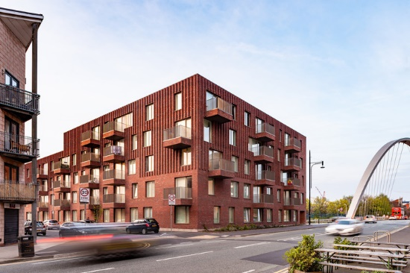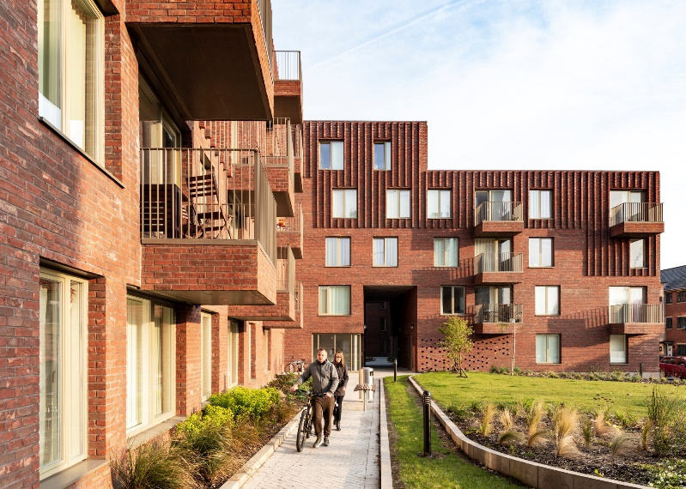

PARTICIPANTS

sTOYAN GROZDEV

MILAN MILANOV

BORIS MARINOV

DATE: 20/04/2022 – N.D

**TABLE OF CONTENTS**

1. Inroduction
2. background
3. problems

3.1 CLEANING FACILITIES

3.2 GROCERIES FOR SHARED ITEMs

3.3 GARBAGE DISPOSAL

3.4 UNANNOUNCED PARTIES

3.5 INTRUSIVE LANDLORD

3.6 LOUD OR ANNOYING HOUSEMATEs

3.7 OTHER PEOPLE’S PARTNERS

3.8 BROKEN FACILITIES

1. solutions

4.1 CLEANING FACILITIEs

4.7 GROCERIES FOR SHARED ITEMS

4.3 GARBAGE DISPOSAL

4.4 UNANNOUNCED PARTIes

4.5 INTRUSIVE LANDLORD

4.6 LOUD OR ANNOYING ROOMMATE

4.7 OTHER PEOPLE’S PARTNER

1. problem-solutions overview
2. risk assessment
3. functionalities

7.1 REGISTER/LOGIN

7.2 COMPLAINTS PORTAl

7.3 CALENDAR ORGANIZING TURNs

7.4 PORTAL FOR LANDLORDS

7.5 RULES TAB

7.6 BROKEN ITEM TAB

# INTRODUCTION

The majority of universities students are renting an apartment or a room, and our goal is to help them not only to find the best place to live, within their budget, but also to improve the staying in our housing by finding solutions to common problems they have to face on a daily basis. We will develop a software application that will be able to find these solutions and help our tenants to enjoy living in our accommodations.

# USER DESCRIPTION

Students

Student housing BV has the goal to help as much students as possible all around the world. The whole idea is to help international students find the best place to live in during their study in the Netherlands. For example, most of Dutch students have a place to stay during their study, but the internationals ones, from all around the world, need an apartment to live in. That is where Student Housing BV comes in hand. Our clients are mostly international students, with a little percentage of Dutch students that are moving to another city or just do not want to live with their family anymore.

These people are all searching for a new place to live in. We try to help them finding a place that suits all their needs. As students, most of them have specific budget that they need to fit in. We take all their wishes in consideration and do our best to help them find what they need. Of course, there can be some people that are not students, but most of our clients are students trying to find a place to stay in in the Netherlands.

Administration

Of course, there is some other people that are going to use our program as well. In our software you can log in as an administrator of Student Housing BV and see all the information you want. You are able to find everything for each apartment and for each person. This way it is easier to keep an eye on everything. And as we know a software should help all of its users and that is our goal as well.

Landlords

Another user that can log in into our Software is the Landlord. If you log in as a landlord you will be able to find everything you need for your own apartment. The difference between the landlord and the administrator is that the landlord is able to see the information about only one apartment

– his own and as an administrator you are able to see every single information you are looking for.

# PROBLEMS

## **Cleaning Facilities**

One of the main problems is how to organize the cleaning schedule in order to have always a more or less clean apartment.

This problem is extremely common when there is a lack of communication and organization. Students have many things to do in a day therefore it easy for them to forget to clean or repeat in their minds “I will do it later”.

## **Groceries for shared items**

In an apartment with other people, it is obvious that there are going to be some items that needs to be shared like dish soap, paper toilet and many others. A lot of times there are only one or two people buying these items for everyone, which is not fair. It also happens that if one of these things it is finish no one will rebuy it, which can lead to some inconvenient situations.

## **Garbage disposal**

Every week, once a week, the garbage should be taken out the night before and taken in in the morning.

Unfortunately, it often happens that students forget to take the trash out and this could be a really big problem especially of big student houses, which produce a lot of garbage.

In fact, there are 2 different types of garbage, and each type is taken every other week so if the trash is not taken out in the due day it will have to wait 2 more weeks.

In addition, this can cause the presence of insects and mice

## **Unannounced parties**

Unannounced parties can be very annoying especially it they happen all the time and they are noisy. When having an announced party, it can get very loud for other roommates and perhaps also messy where the party is located in the house. Unfortunately, a lot of people have to deal with this problem and can cause a conflict between roommates if this happens a lot

## **Loud or annoying housemates**

Having loud or annoying housemates can be one of the most annoying things have experience in your student house. This problem can disturb other roommates when they are working or studying and more.

## **Other People’s Partners**

When one of your housemates has their boyfriend or girlfriend over that’s fine, but if they stay for a long period of time this can be problematic. There can be a problem with the landlord if there is someone living there who isn’t on the tenancy.

## **Broken Facilities**

When something breaks in a student house this can be a problem for

everyone. This can be dangerous depending on what breaks and also

annoying for other people if they also use these objects for their daily life.

When something breaks no-one really wants to repair or get a fixed

version of the object that is broken.

# SOLUTIONS

## **Cleaning Facilities**

Our solution for this problem is to create a weekly schedule.

This schedule would be created so that the facilities to clean are divided equally between the tenants and it is not always the same person who cleans.

The main idea would be to create 2 lists:

- The first one will keep track of the information about the students in the house (for example the name or the room number).

So, we will declare the list

And then add in our design a text box where the user is able to add

the tenants’ names and these will be added to the list

* For the facilities, our application design will be provided with some checkboxes and combo-boxes to choose the facilities that the house present and the number of rooms per kind.

To be clearer each check box will represent a share facility:

* + Kitchen
  + Living room
  + Bathroom
  + Hallway
  + Outdoor space
  + etc.

A text box should also be provided so that if one facility is not in presented in the check box the user is able to add it himself.

All these information will be stored in another List (ex. “Facilities”)

Based on this information we can make a weekly/monthly cleaning agenda.

The program should be created in order to make a sort of periodical cycle so that all the tenants, at the end of the cycle, will have done the same amount of work.

If, for example, there are 4 students and the house has a kitchen, a living room, a bathroom and 1 toilet, the program should create an agenda similar to this:

### KITCHEN LIVING ROOM BATHROOM TOILET

|  |  |  |  |  |
| --- | --- | --- | --- | --- |
| DATE | Tenant 1 | Tenant 4 | Tenant 3 | Tenant 2 |
|  |  |  |  |  |
| DATE | Tenant 2 | Tenant 1 | Tenant 4 | Tenant 3 |
| DATE | Tenant 3 | Tenant 2 | Tenant 1 | Tenant 4 |
| DATE | Tenant 4 | Tenant 3 | Tenant 2 | Tenant 1 |

## ***4.2* Groceries for shared items**

In this case the solution that we would like to propose is a common bank.

The concept of the common bank is that each tenant should give a small sum of money every month to buy the shared items like paper toilet, dish soap etc.…

The user, with our software application, should be able to give us a monthly budget, which will be divided by the number of students in the house.

Every month a tenant will have to buy the items with the money that himself, and the others gave him.

Every time a student is in charge to buy the shared items, he should always provide the recipe so that it is sure that no money is stolen.

In the case where the bill is less than the money given the rest should be keep for the next month.

### TENANT IN CHARGE

|  |  |
| --- | --- |
| DATE | Tenant 1 |
| DATE | Tenant 2 |
| DATE | Tenant 3 |

## **4.3 Garbage Disposal**

The best solution we found to solve this problem is to make a monthly or weekly schedule. Every week, once a week, the garbage should be taken out the night before and taken in in the morning. (We should decide if we want it weekly or monthly let me know what you think) The best way to work is to make something like what we did to organize the cleaning.

TENANT IN CHARGE

|  |  |
| --- | --- |
| DATE | Tenant 1 |
| DATE | Tenant 2 |
| DATE | Tenant 3 |
| DATE | Tenant 4 |

## **4.4Unannounced parties**

The best solution to this problem is to set a monthly limit to the parties that can be thrown per person.

The tenant that wants to throw the party should ask in advance to the other tenants and after the party everything should be clean.

A possible solution for this is asking 1 week prior to the date that you want to have a party in your house. For example, if you register on November 10th, then you can throw a party 1 week after it, in this case 17th of November.

“Meeting” in the tenant’s room should not be considered as parties as long as too much noise is not made read it

## **4.5 Intrusive Landlord**

Set a monthly limit to the times that the landlord can visit the house and the tenants.

Each visit should be announced at least 1 week before.

## **4.6 Loud or Annoying Roommates**

When the roommates are being loud or annoying there should be a way to send a warning to them. There will be a limit to how many warnings you can put. If they still don’t comply after a certain number of warnings. Then a complaint will be sent to the landlord after he or she exceeds the limit of warnings.

## **Other People’s Partners**

A way to avoid this problem is to set a general rule by making by not letting the housemate’s boyfriend or girlfriend stay for more than 2-3 nights or if more, then you should advice the housemates prior so they will now around how long they are staying for.

## **Broken facilities**

Everything could break in our apartments. It happens. It is possible and we do not hide that from our clients. What will happened in this case scenario? First our tenants need to inform us so we can take this into consideration. We will send a man to the address and he will check, if the problem is fixable. Most of the things could be fixed, but it is possible that the item or the machine needs to be replaced. In this case we will do our best to analysis if the problem was made from the tenant or for example the problem could be in the machine, so if the problem is just the machine getting old, we will fix it and be responsible to replace it, but if the tenant broke the machine, they need to pay for it. This is our rules about braking facilities.

# PROBLEMS-SOLUTIONS OVERVIEW

PROBLEM SOLUTION

|  |  |
| --- | --- |
| CLEANING FACILITIES | Create a weekly schedule |
| GROCERIES FOR SHARED ITEMS | Create a common bank |
| GARBAGE DISPOSAL | Create a monthly/weekly schedule |
| UNANNOUNCED PARTIES | Set a monthly limit for parties |
| INTROUSIVE LANDLORDS | Set a limit of visits per month |
| COMMUNICATE THE PROBLEMS | Create a portal (our software application)  where the user can register |
| LOUD OR ANNOYING HOUSEMATES | Make it possible to complain about a housemate, and if the complains are too  many the rent price will get higher |
| OTHER PEOPLE’S PARTNERS | Set a limit to the number of days the  partners/friends can stay in |
| BREAKING FACILITIES | Request change for the broken part |

# RISKS AND MANAGEMENT

* 1. In the unfortunate case where one of our co-workers gets infected with Covid-22 or any other illness that will make it for him not possible to attend the meetings

The concerned ones, will, when possible, attend the meetings on-line.

* 1. If our hardware is damaged or there are technical difficulties

There will be a replacement of a sort or a change of working location, the university will be able to provide a temporary solution to continue to work and deliver the software in time.

* 1. If there are unexpected difficulties with the software application that will slow down the project progresses

There is going to be a spontaneous change in the schedule

* 1. If we come up with new features to implement our program

The project analysis will be updated including the new features and functionalities.

# FUNCTIONALITIES

For our Software application we are going to implement some functionalities that the users will be able to see in the GUI (Graphic User Interface).

## **Register/Log in**

Whit this functionality the user will be able to register in our software or log in if he already has an account. This will make it possible to access to all the other functionalities.

## **Complaints Portal**

Here the user can send complaints to the Students Housing Bv where they are going to be processed and take in account.

In this functionality the following problems are included:

* Other people partners
* Pets
* Idk maybe something else also?

## **Calendar organizing turns**

This functionality will be used to provide to the user a detailed calendar with turns and how to organize the activities.

In this functionality the following problems are included:

* Cleaning Facilities
* Garbage Disposal

## **Portal for landlords**

With this portal the landlords will be able to “book” a visit to the house so that the house members will know in advance when the landlord will come. This will partly solve the problem with intrusive landlords.

## **Rules tab**

We are going to create a dedicated page to what the rules that the tenants should follow are.

In this the following will be included:

* Unannounced parties.
* Other people’s partners

## **Broken item tab**

Another tab will be created to try to solve the problem of broken facilities.

**FUNCTIONALITY PRIORITY**

|  |  |
| --- | --- |
| REGISTER/LOG IN | Must |
| COMPLAINTS PORTAL | Must |
| CALENDAR ORGANIZING TURNS | Must |
| PORTAL FOR LANDLORDS | Should |
| RULES TAB | Must |
| BROKEN FACILITIES | Could |
| DATABASE IMPLEMENTATION | Should |
| USING ARDUINO | Will not |